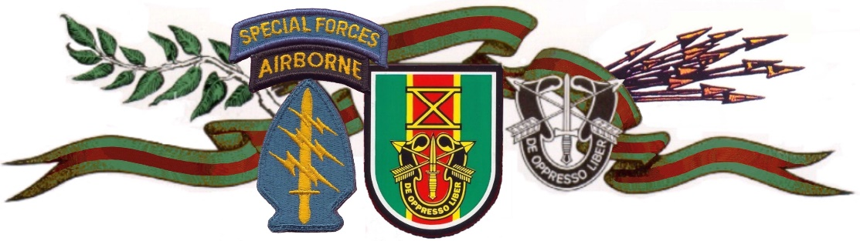

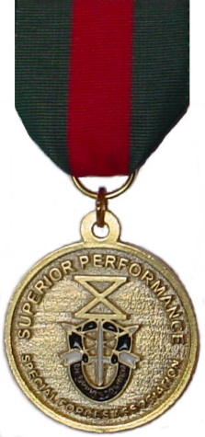
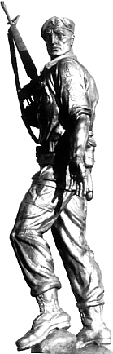
Special Forces Association
The Award of Excellence
Is hereby presented to:

Cadet XXXXX
In keeping with the Traditions and Ideals of the United States Army Special Forces Soldier’s Knowledge, Proficiency, Leadership, And Dedication to Mission, during the year 2021 - 2022 as a Cadet of
XXXXXX High School Junior ROTC Program

